**Task 1**

Regex Symbols in Linux

1. grep '^himanshu' testfile.txt : it will return lines starting with word Himanshu
2. grep 'rajpoot$' file.txt : it will return lines ending with the word rajpoot
3. grep '[0-9]' file.txt : It will return lines containing digits from 0-9
4. grep 'lo*se' file.txt : It will match the pattern. It can return Lose, loose or looooooose.
5. () – Grouping Expression :

grep -E '(cat|dog)' AnimalsFile.txt. It will match either cat or dog using group function

1. ? – Zero or One Occurrence : grep 'colou?r' file.txt It will return color or colour. Even if u is not present, it will return the string

**Task 2**

**Linux OS**

It is an open source operating system. Just like Windows or macOS, but it's usually faster, more secure, and gives more control. It is very secure and fast. We can customize the linux. We can change almost everything about how it looks, works, or behaves. Linux also supports multiple users and multitasking, so many people can use the same system without interfering with each other. It includes powerful tools and makes automation and scripting easy.

**Task 3:**

**Kernel:**

Kernel is the brain of a computer. It sits between computer hardware and software or apps that we use. Whenever we open a program, type on your keyboard, or save a file, the kernel is quietly working behind the scenes to make sure everything runs smoothly. It decides which programs get to use the processor, manages how memory is shared, and handles communication between software and hardware. It also protects your system by making sure that if one app crashes, it doesn’t take down everything else.

**Task 4**

**BASH:**

BASH is a command-line tool in Linux. It’s like a text-based way to talk to your computer. Instead of clicking buttons or icons, you type commands—and the computer does what we ask.

**Task 5:**

**Difference between Linux and Windows Operating System.**

**Cost:**

Linux is free whereas Windows is a paid operating system.

**Control:**

Linux is open source so we can change the code whereas we cannot make changes to windows

**Security:**

Linux is very secure, it has fewer viruses. Hackers usually target windows systems by viruses and malware.

**Customization:**

Linux is highly customizable, we can change everything. Windows has less options for customization.

**User Type:**

Linux is usually used by programmers whereas windows is used by general users.

**Ease of Use:**

Linux requires some initial learning to know the commands to operate whereas windows is easy to use.

**Speed:**

Linux is lightweight so it is very fast however windows can become slow with older systems.

Task 6:

Components of Linux

Linux has 5 components:

1. **Kernel**: Kernel is the core part of Linux. It connects software and hardware. It manages CPU, memory, and devices.
2. **Shell:** Shell is a program that takes commands from the user and passes them to the kernel. Shell works as a translator.
3. **File System:** Linux stores everything in a tree-like structure. It starts from the root folder and branches out into subfolders like /home, /etc, /bin. It stores and manages data.
4. **System Libraries:** These are collections of pre written codes that apps can use.

They help programs perform tasks like printing text, opening files, and connecting to the internet.

1. **Applications:** these are programs that we install and run like web browsers, media players and editors.

**Task 7:**

Is it legal to edit Kernel? When do you think we have to in case?

Since it is open source, it is legal to edit the linux kernel. Anyone can view, modify and share kernel’s code. It is licensed under GNU GPL (General Public Licensing)

The scenarios where we might need to edit the Kernel

**Perform Optimization:** We can remove unused parts and make linux faster.

**Security Hardening:** We can add special security features. In bank, defense systems, normal security isn’t enough. We may customize it to add an extra layer of protection.

**Learning or Experimentation:** Developers can change the code to learn how it works.

**New feature:** If we want to add new features, we can modify the kernel.

**Task 8:**

**What is LILO?**

LILO stands for Linux Loader. It is a boot loader for Linux. It helps to start the computer and load the Linux operating system.

When we open the computer, the system doesn’t know what to do right away. LILO tells the computer where to find and how to start Linux.

**Task 9:**

**What is Shell? How many Shells are There and what are they?**

Shell is a program that lets you talk to the linux system by typing commands.

It takes what we type, interprets it and sends it to the kernel to be executed.

**We type Commands -> Shell reads it -> Kernel does.**

There are many types of shell but most commonly used is BASH

Bash

Sh : the original unix shell. It is simple and basic. Bash is based on Sh.

Zsh : it is similar to bash but it comes with more powerful features like auto suggestions.

Ksh: KornShell, is used in enterprise environments. It allows faster scripting.

**Task 10:**

**What is Swap Space?**

Swap Space in Linux is like a backup memory. Our computer has RAM which is fast and used to run programs. If RAM gets full, Linux uses a part of the hard drive called swap space to help.

It moves less used data from RAM to swap so the system can keep running smoothly.

**Task 11**

**What isMount? How do you mount and unmount a file system in Linux?**

In Linux, mounting means connecting a storage device to your Linux file system so we can access its files.

To mount:

When you plug in your USB, Linux detects it and creates a device file for it (like /dev/sdb1).

If the USB is not inserted, that device path won’t exist — and the mount command will fail.

1. Create a mount point (a folder where you want to access the device)

Sudo mkdir /mnt/myusb

1. Sudo mount /dev/sdb1 /mnt/myusb

How to unmount?

Sudo unmount /mnt/myusb

Sudo unmount /dev/sdb1

**Task 12:**

What is the chmod command? How to use it?

Chmod command is used to change permissions of a file or folder like who can read, write or run it.

It has 3 groups

Owner (U)

Group (G)

Others

There are 3 permissions

R - Read

W - Write

X - execute

If I want to give permission to owner I will use

Chmod u+x [file.sh](http://file.sh)

**Task 13:**

Can you add a new user account?

Yes, a new user can be added with

Sudo adduser rajpooth

Then set the permission

Chmod a+x /home/rajpooth

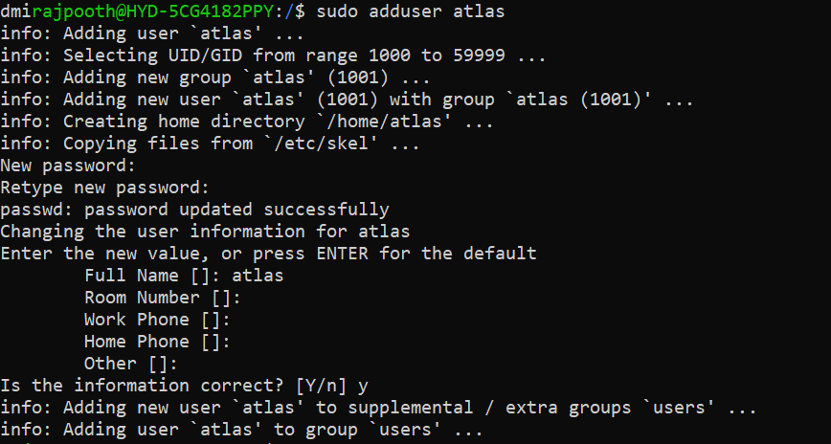

**Task 14:**

Change password for user

If we want to change the password for current user  
**Command : passwd**

and then it will prompt the enter current password and new password

If we want to change the password for a different user

**Command: Sudo passwd atlas**

**Task 15:**

What is the difference between Process and Thread?

A process is an independent running program. It has its own memory resources and system space. When we use VS code or open a fireFox it has a separate process.

Thread:

Thread is a small unit of a process

Multiple threads share the same memory of the process. Threads are like workers inside a process doing different tasks at the same time.

Task 16:

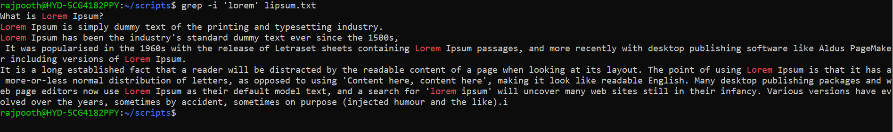

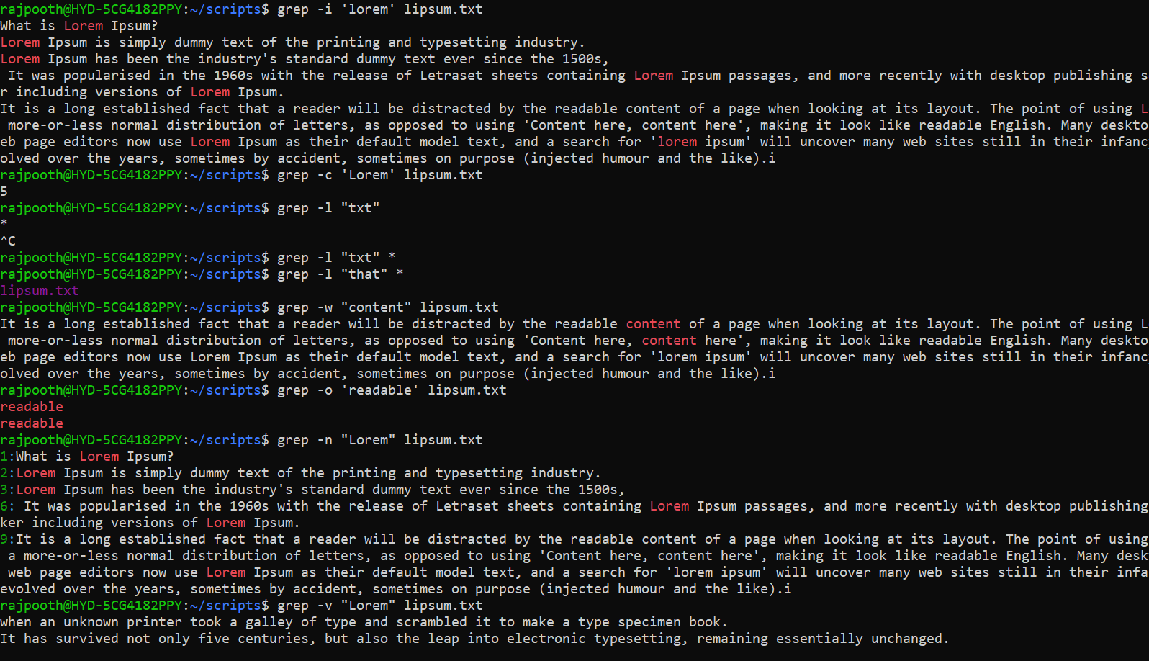

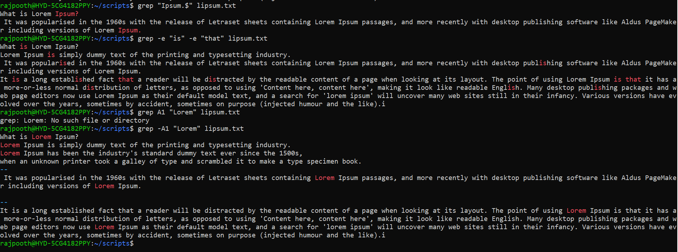

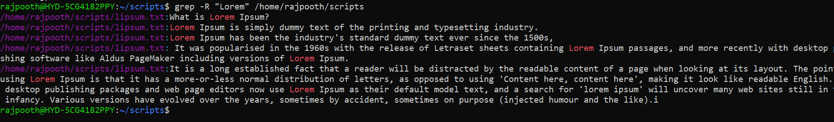

Task 17:

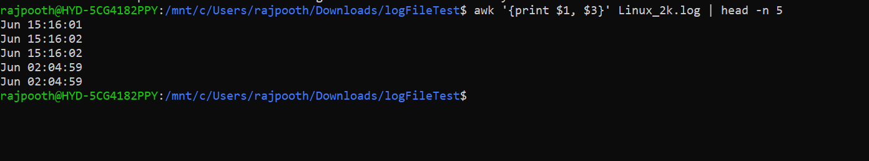

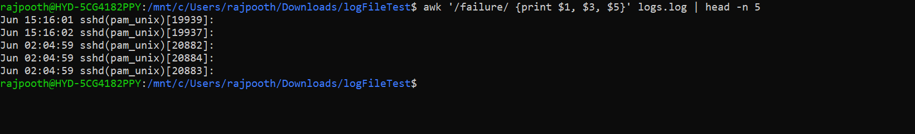

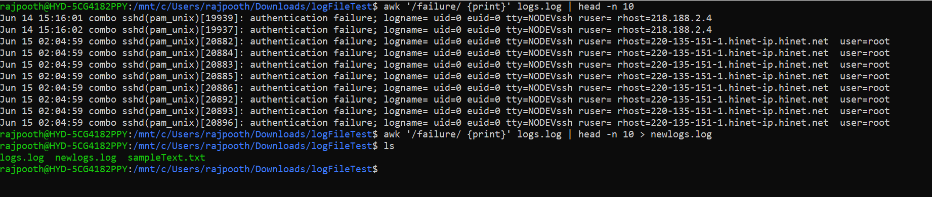

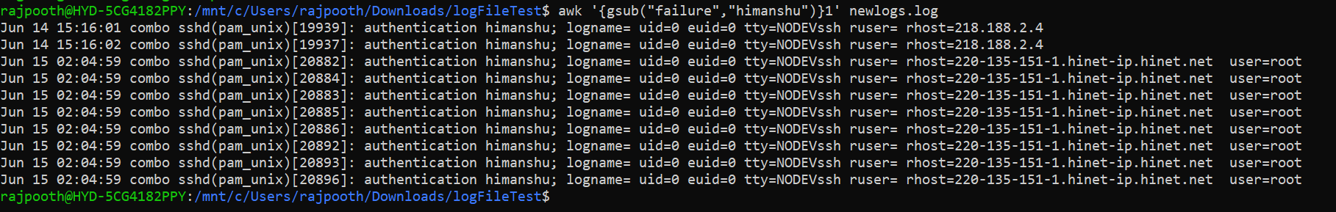

**Task 19:**

What are the default permissions for a new file?

Owner → r w -

Group → r w -

All and others → r- -

**Task 18 & 20:**

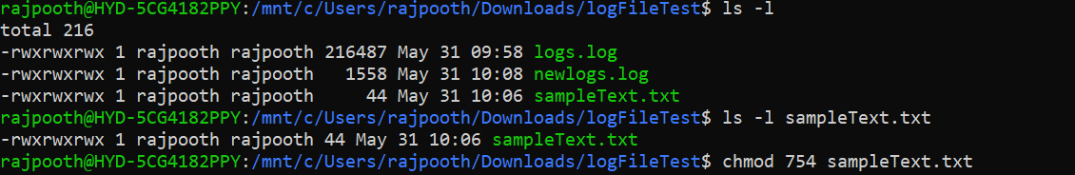

**Task 21**

**Sudo chmod**

**Sudo chmod u=rw,g=r,o= hello.txt**

**Task 22:**

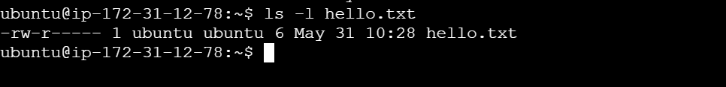

**Task 23 - 24**

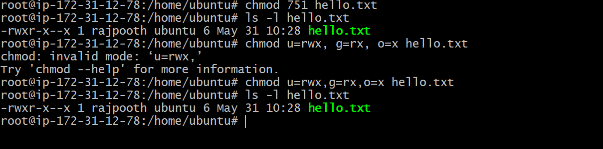

**Task 25:**

It will change the ownership



**Task 26:**

What is a Process?

A process is an independent running program. It has its own memory resources and system space. When we use VS code or open a fireFox it has a separate process.

**Task 27:**

Command for foreground and background process

**Foreground:** ps

**Background:** jobs

Task 28:

Running process

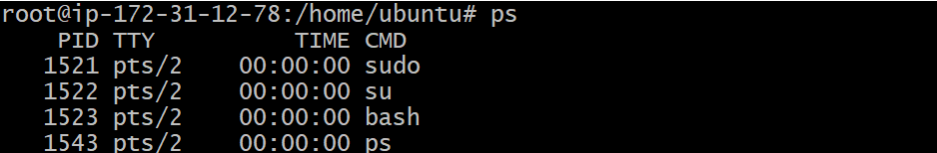

**Task 29:**

It shows detailed information about the processes.

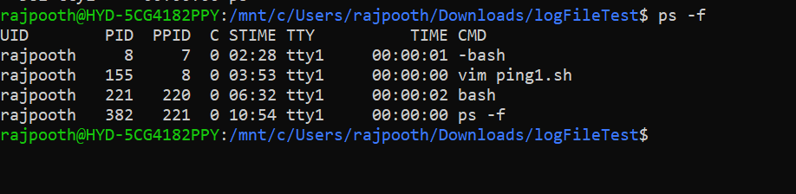

**Task 30:**

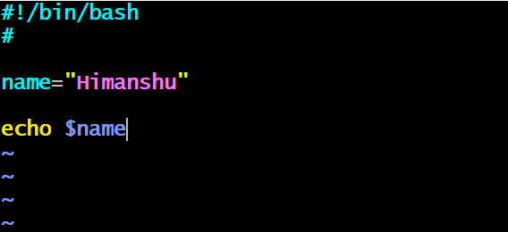

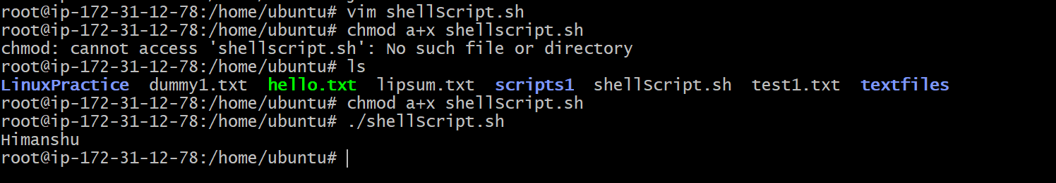

**Task 31:**

**It prints readonly variable**

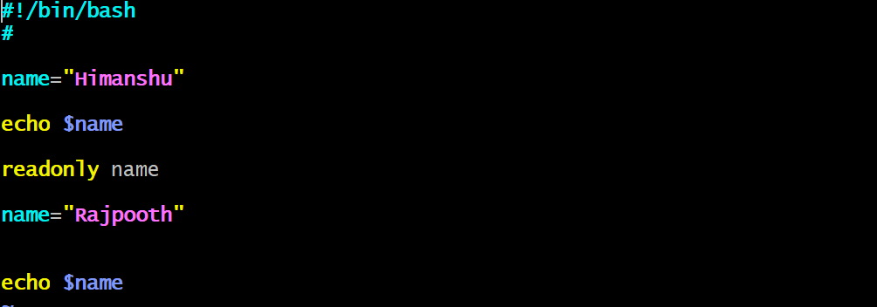

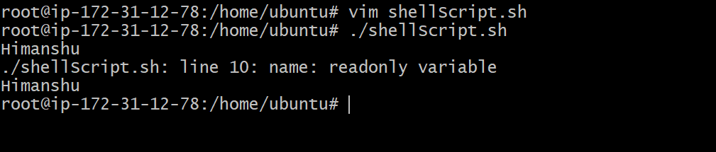

Task 32:

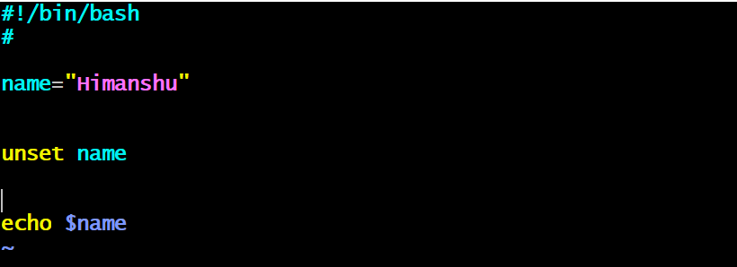



unsetting variables will completely remove it from the shell environment — not just setting it to empty. That's why nothing prints when you try to echo it.

Task 33

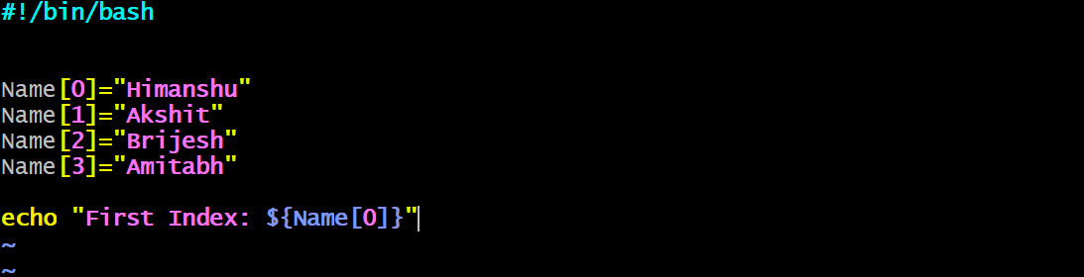

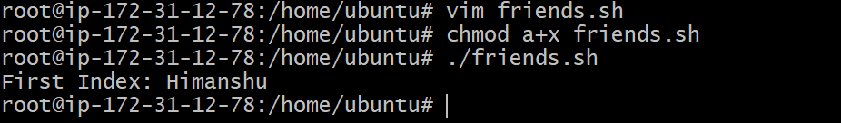

Task 34:

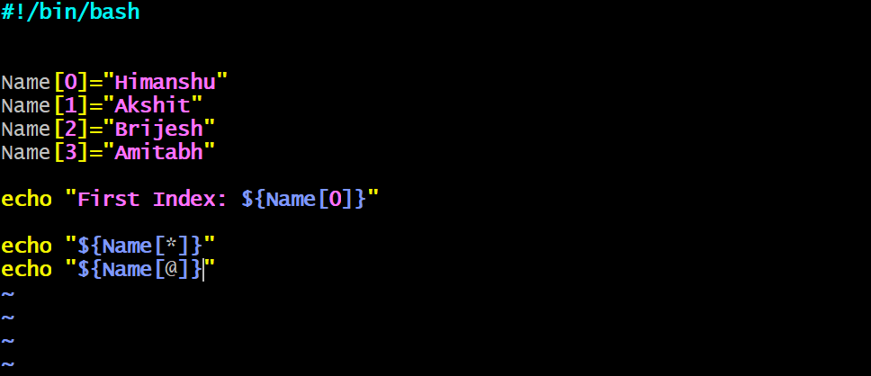

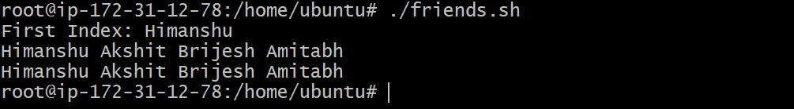

**Task 35**

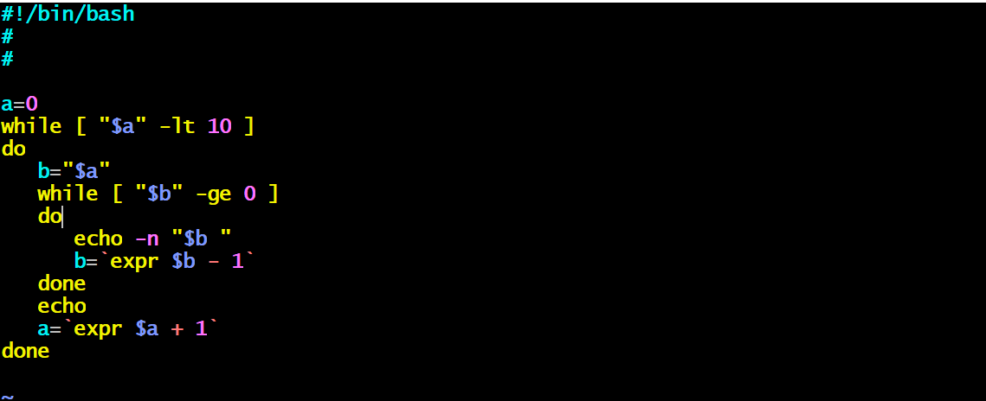

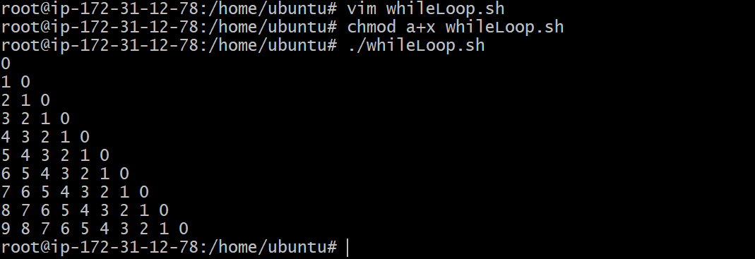

End of File Task

